**IE 6500 Human Performance**

**Lab Report**

Lab 5

Student Name: Jingkang Sun

Date Submitted: 04/13/23

**1.Criterion**

Camera calibration and reprojection pixel error and Calibration parameters

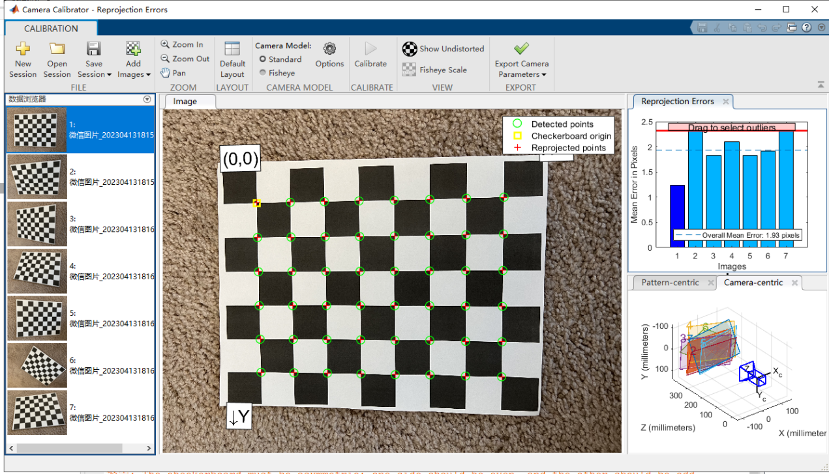

Before calibration

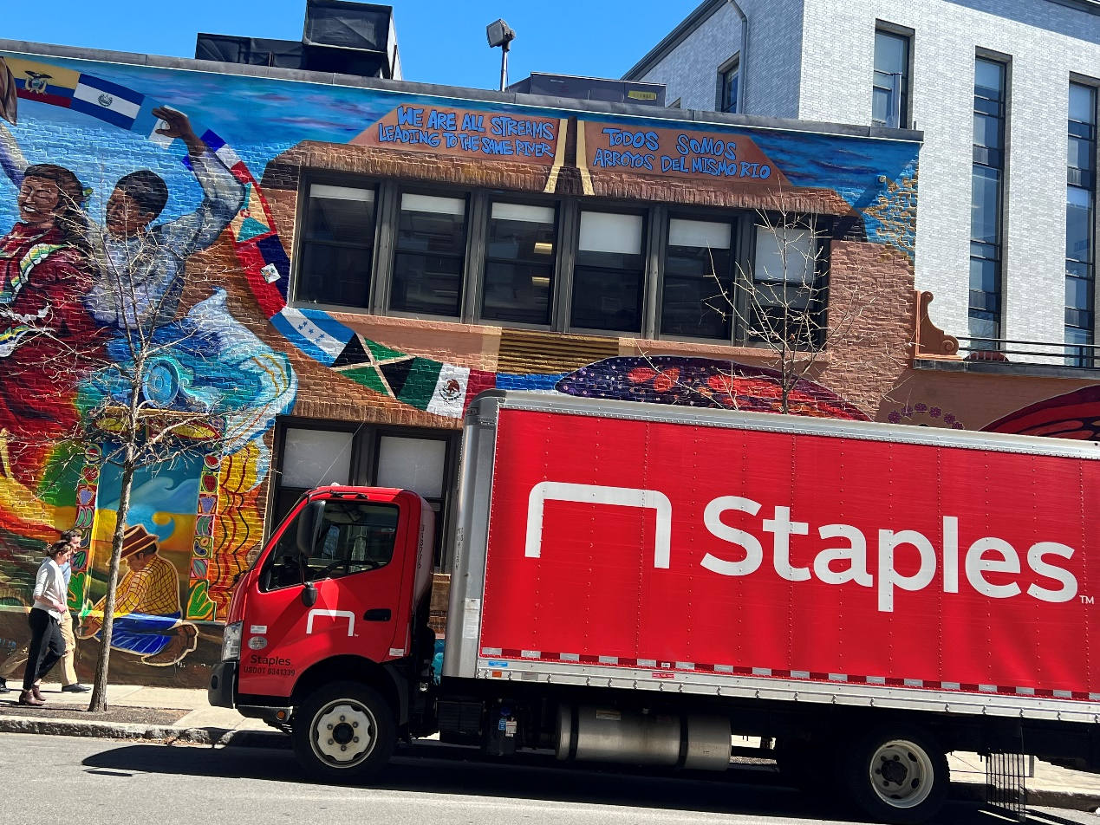

After calibration



**2.LSC mosaic**

LSC image set

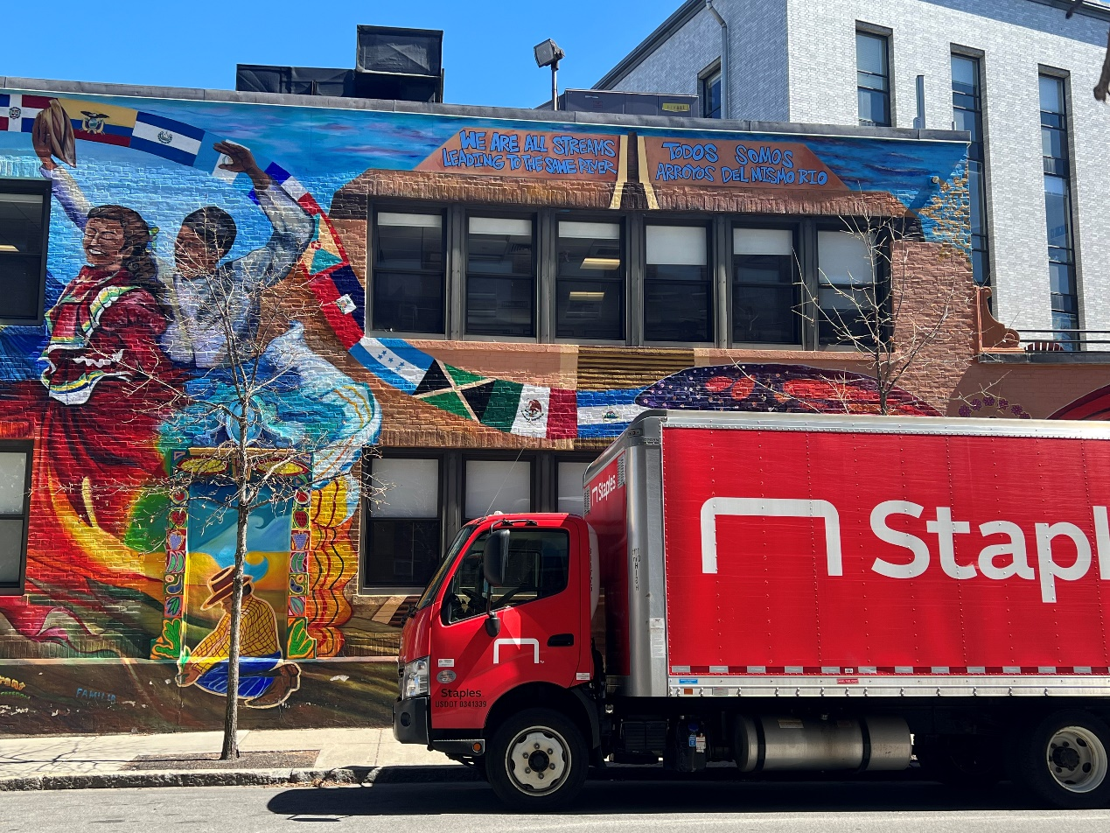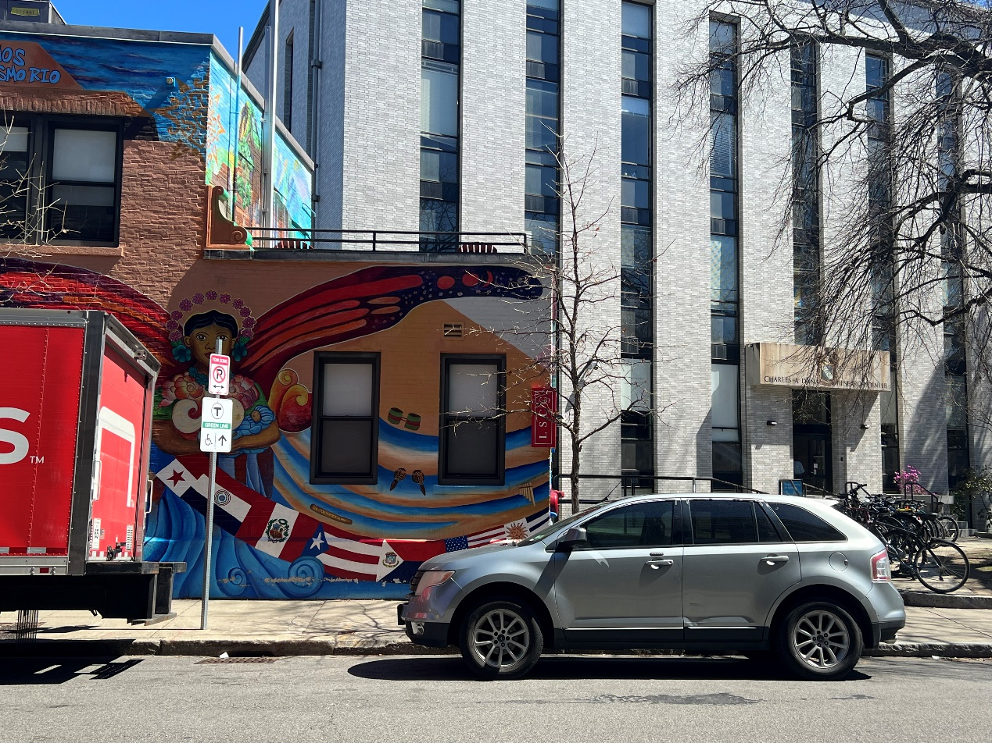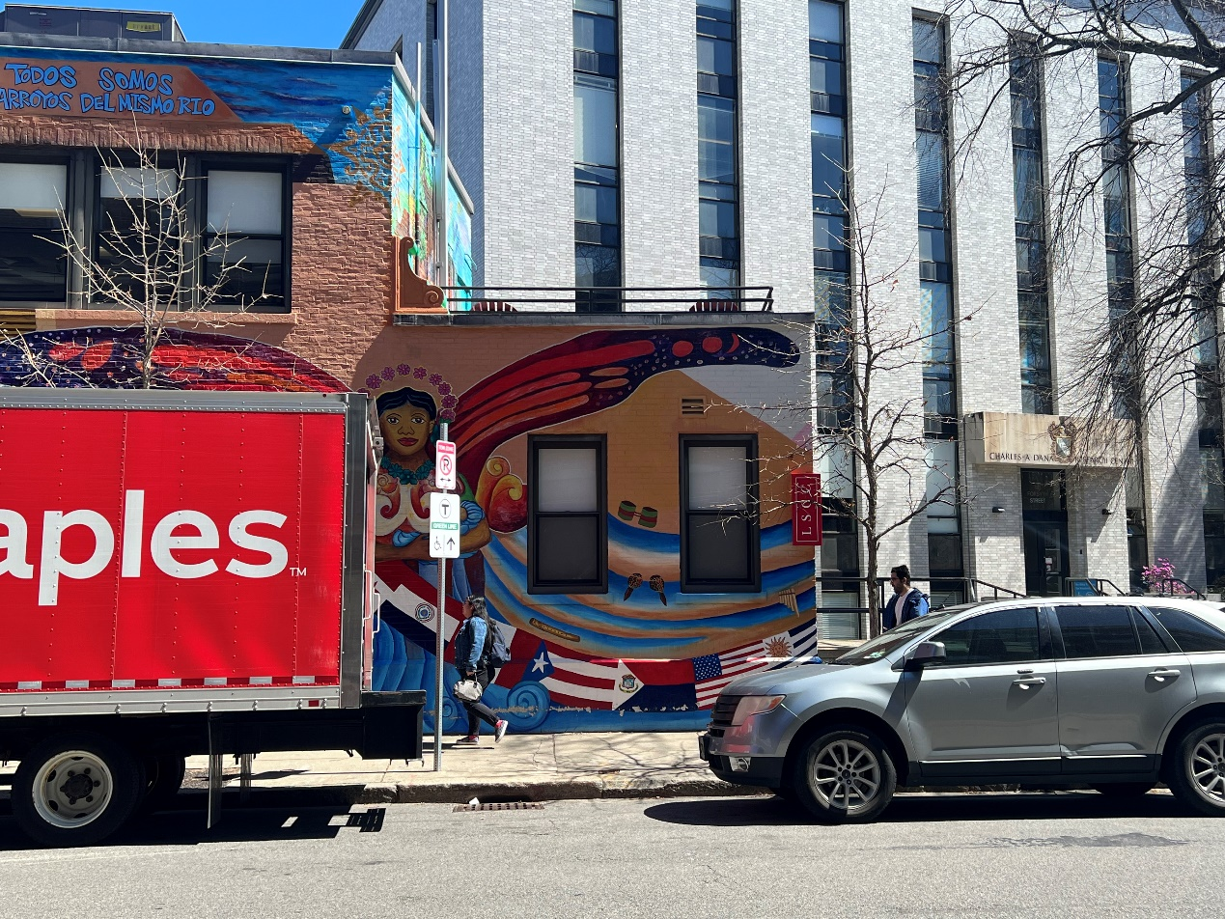

Distribution of Harris corner across LSU image set

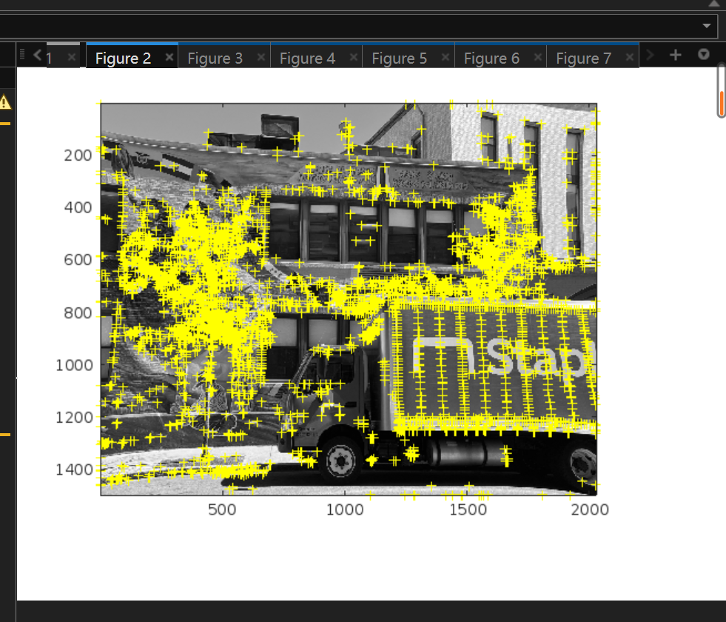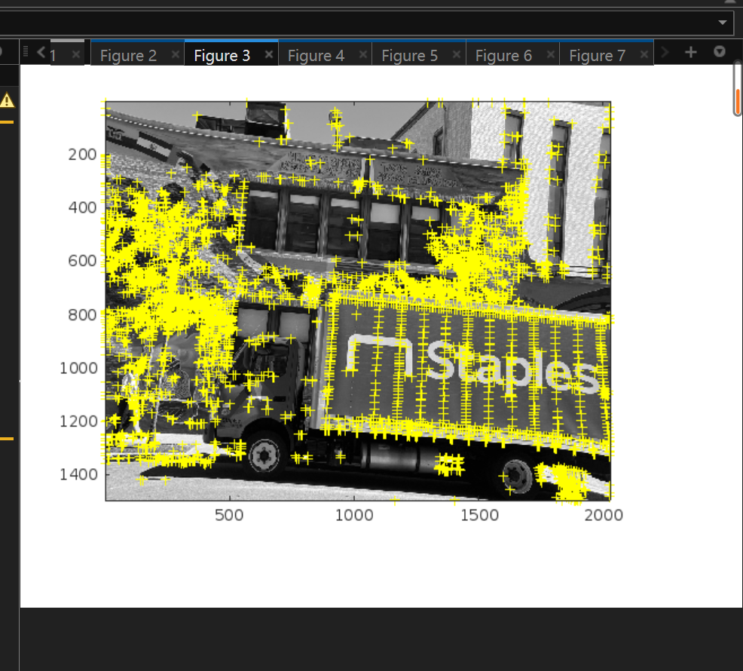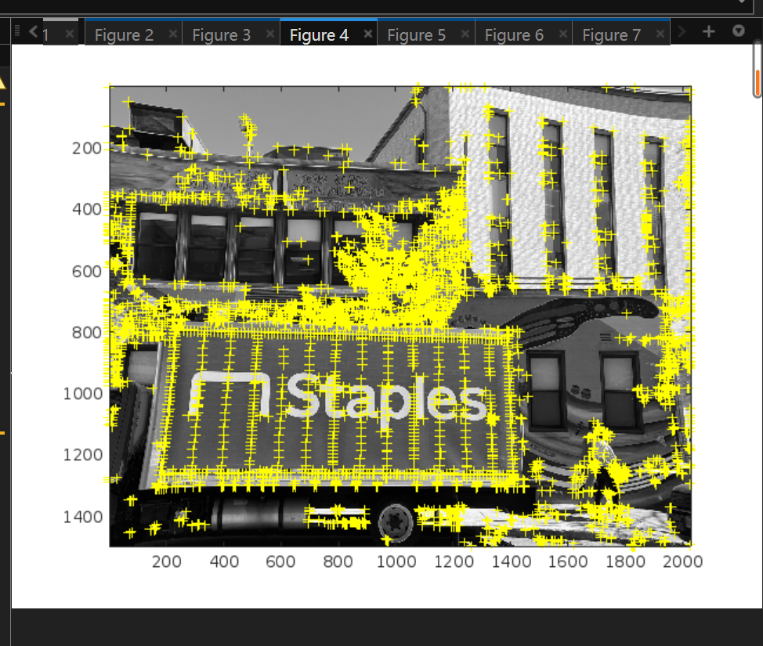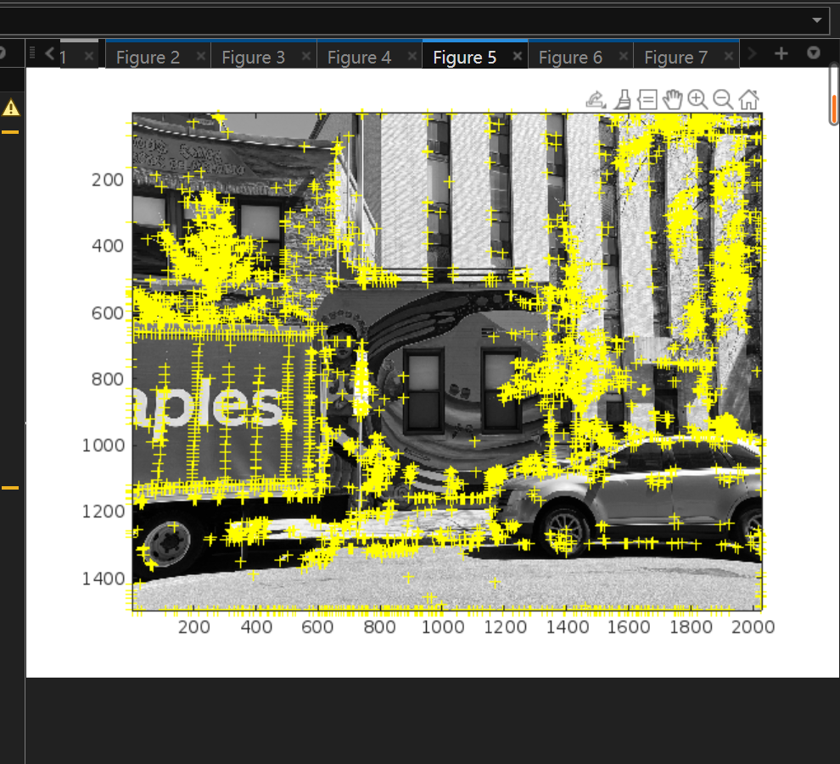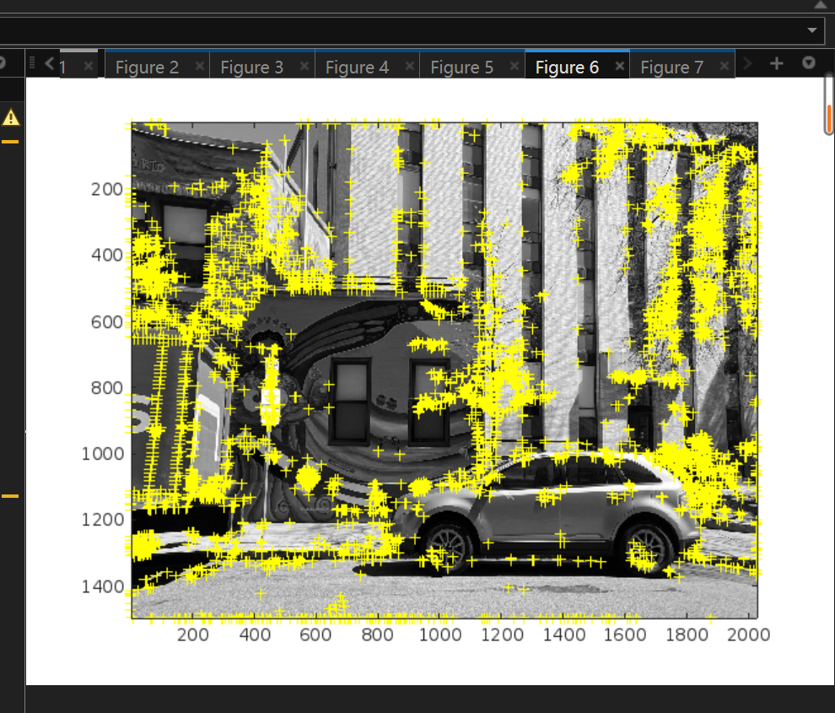

Final LSC image

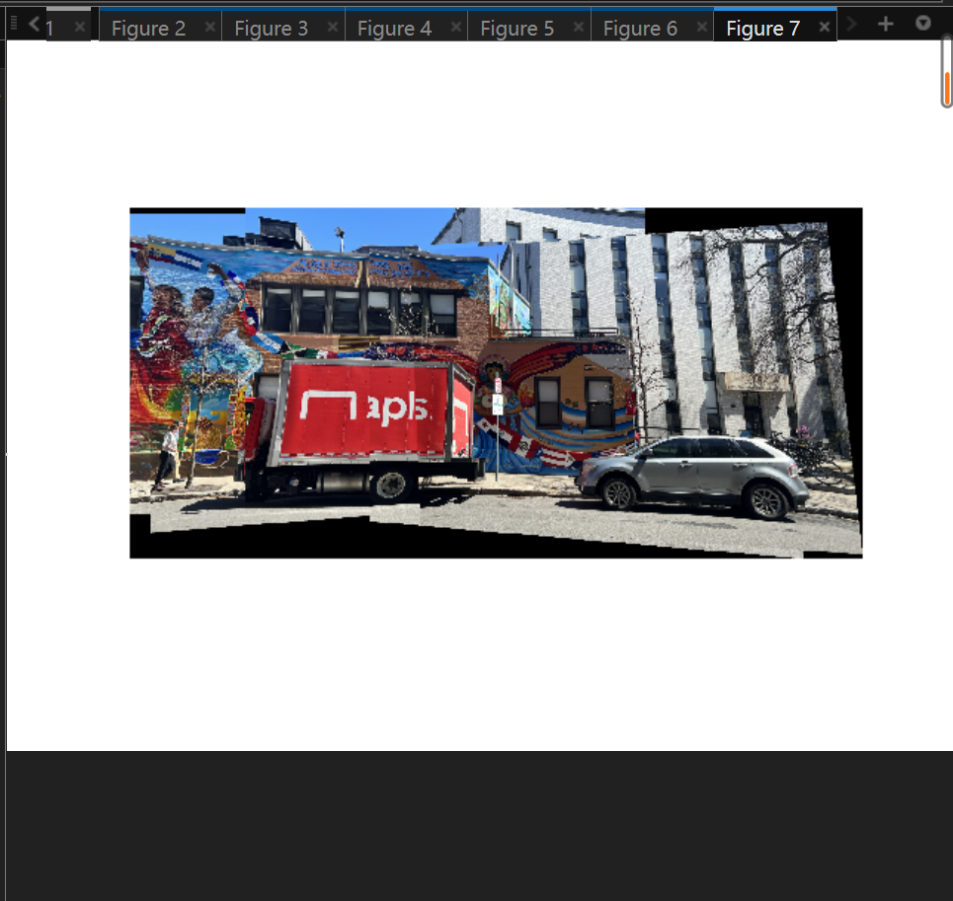

Discussions

Change the code to let the Harris coner point to be 2000 maximum.

**3.Cinder block wall mosaic**

Initial images with Harris corners

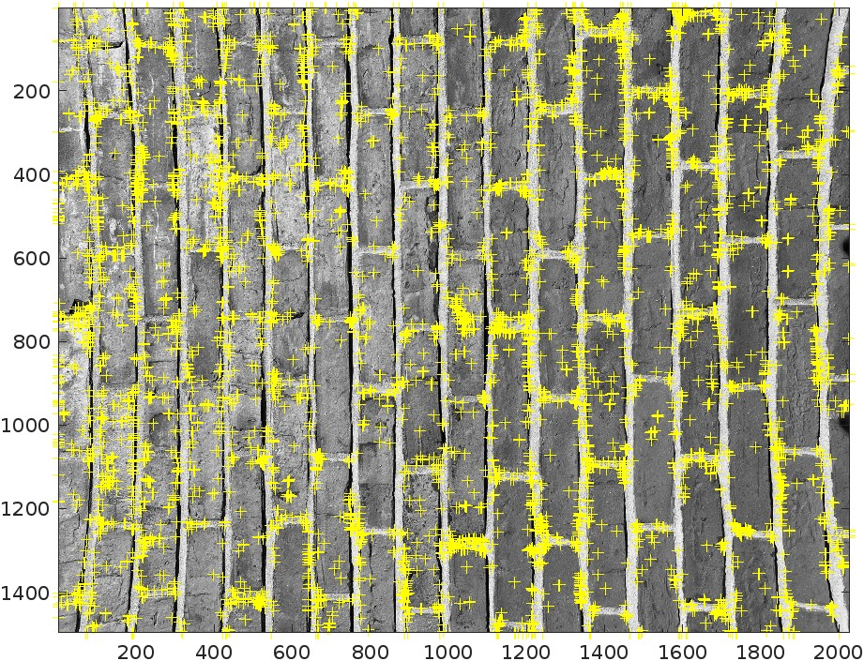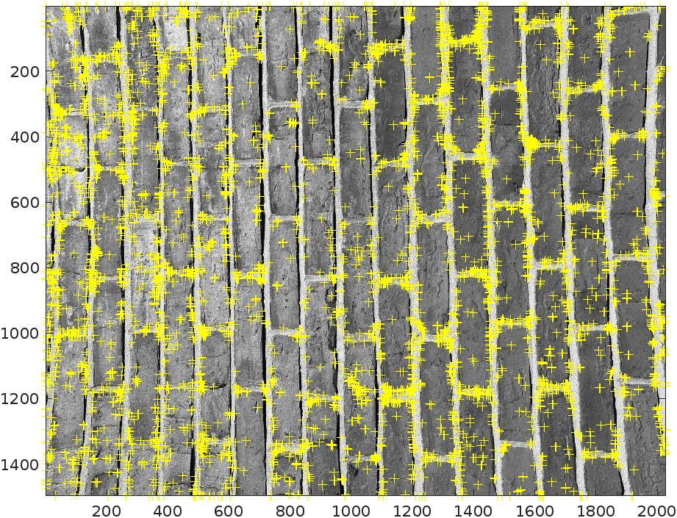

Final cinder block image

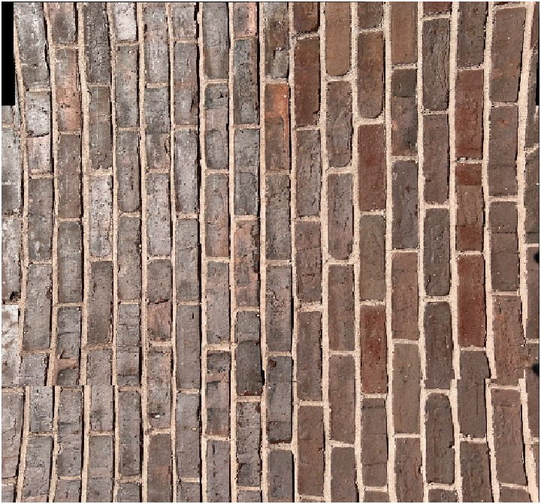

Explanation of cinder

The block wall has a really similar pattern, which will cause the code having a hard time to put it in order. And form a big picture.

**4.Third mosaic**

Initial images with 15%

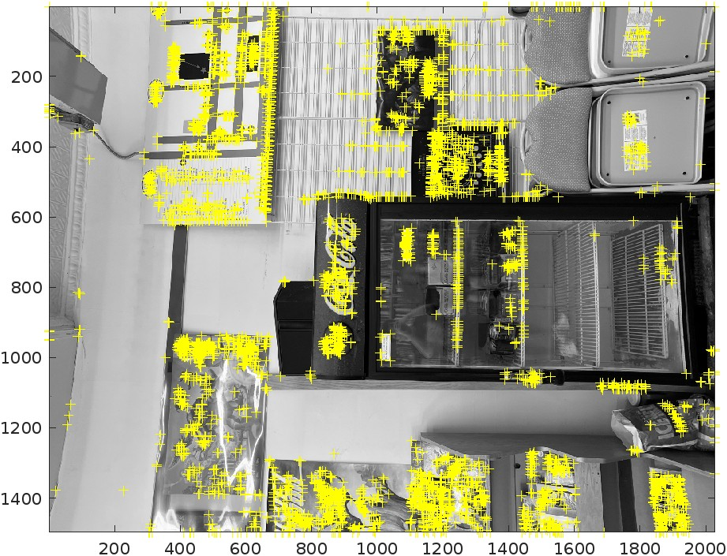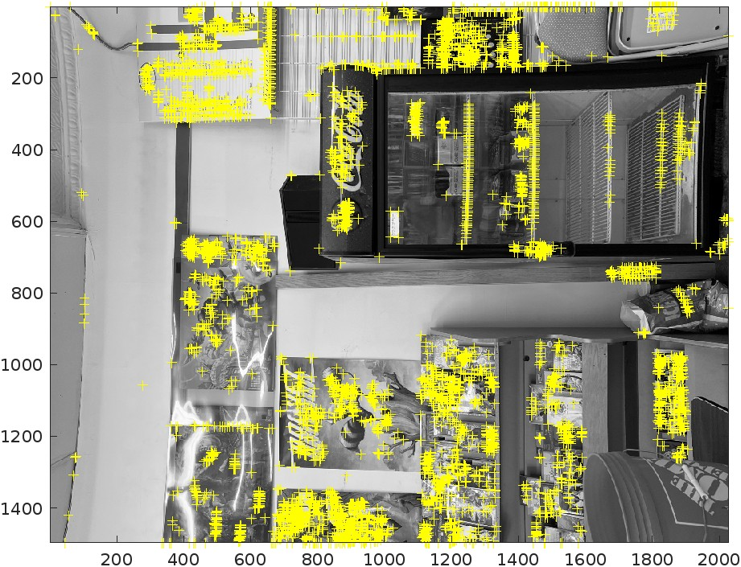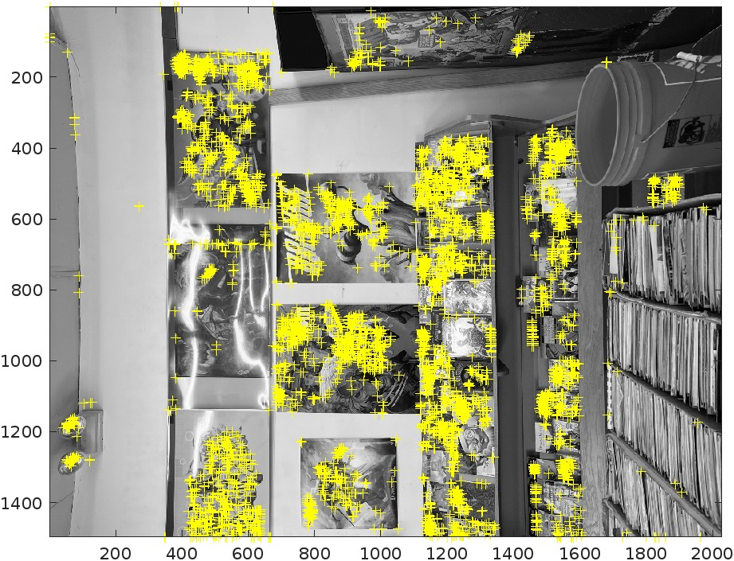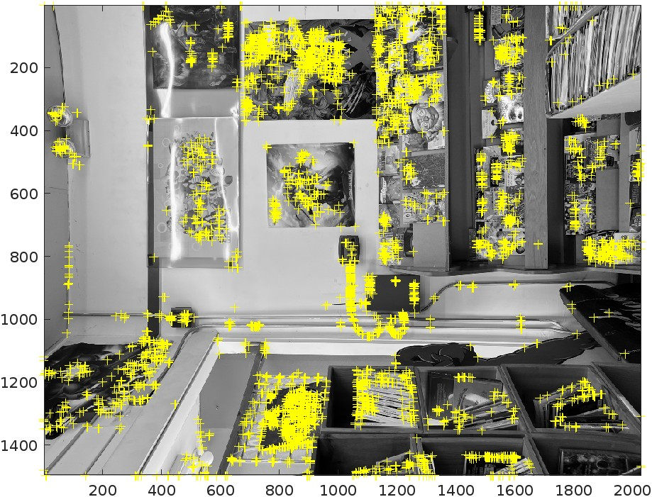

Initial images with 50%

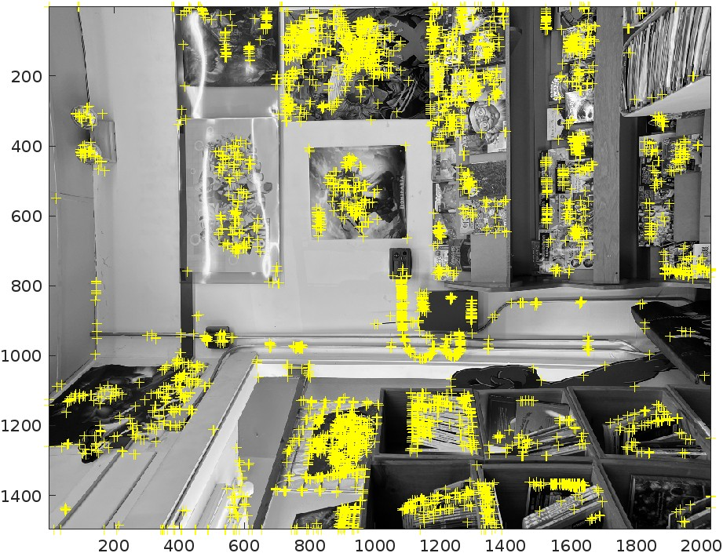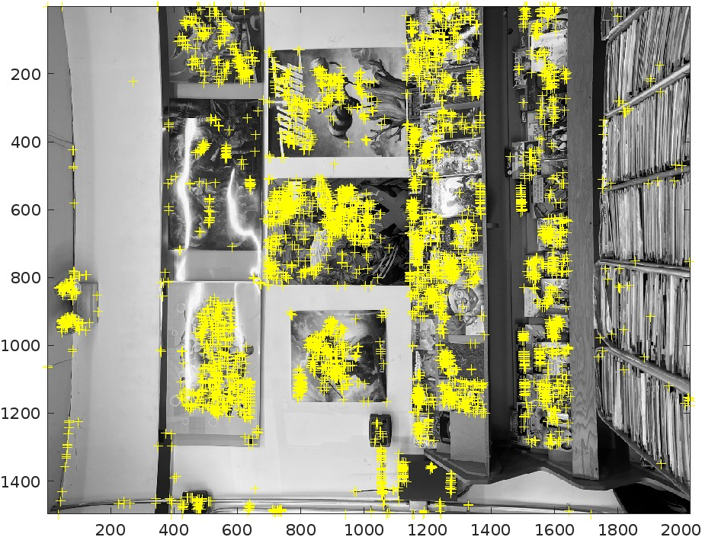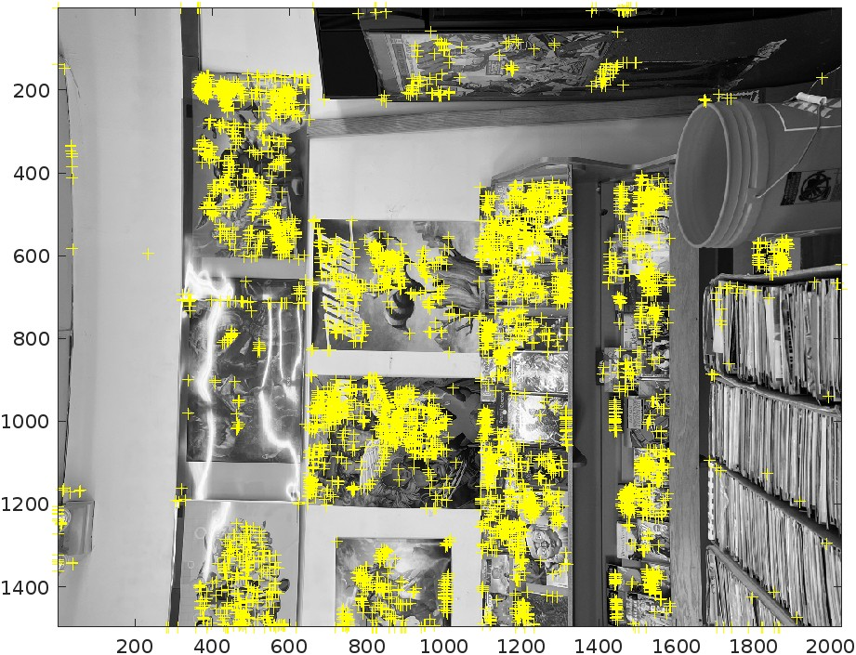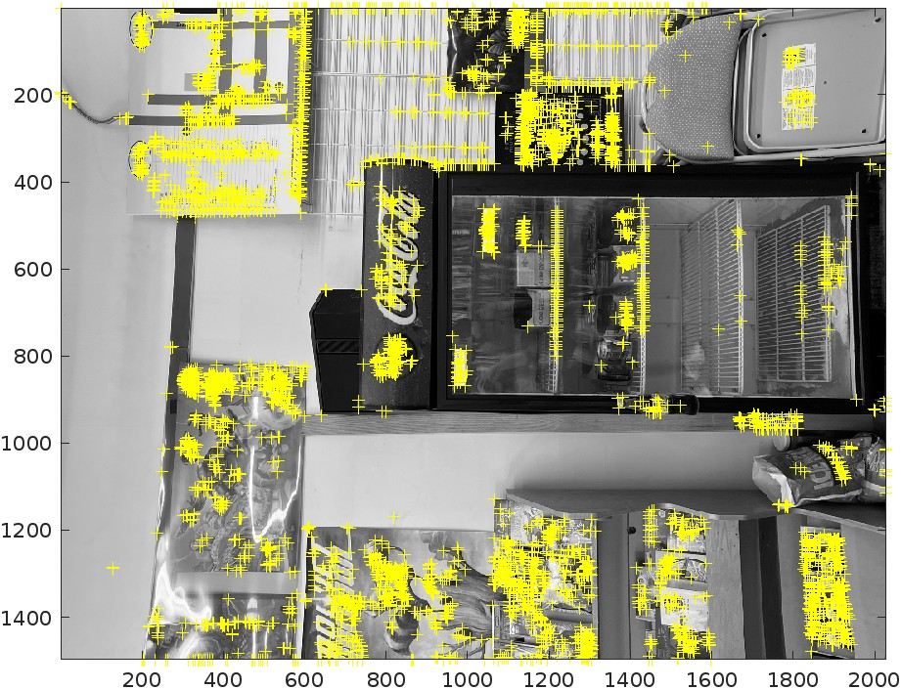

Final mosaic with 15%

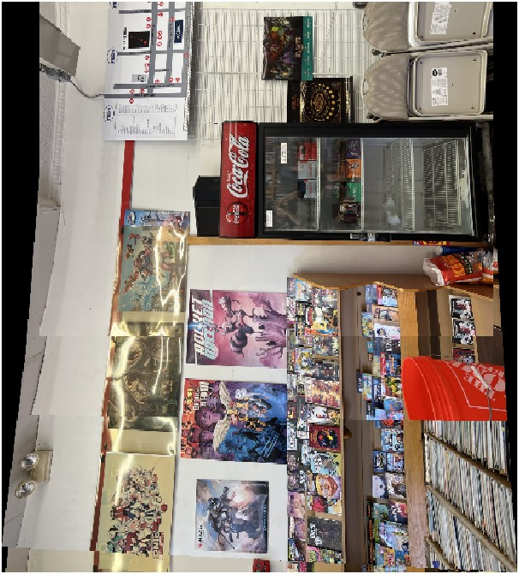

Final mosaic 50%

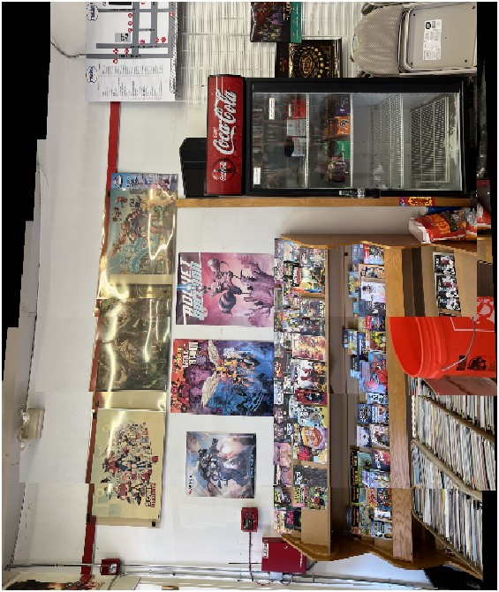

Discussion of performance with 15% and 50% overlap

50% perform better than 15%, the picture has less broke down, the image was more continuous.

Discussion of performance

50% has more matching points than 15%, which means it will be easier for the code to match the picture. It will use less time and if the picture is low quality, it will make the code performance bad. 50% pictures will have more matching points than 15% picture.